Riverbed 1st Time Setup Tasks
========================

Configure IP Primary interface (PRI)
The Primary interface (PRI) this is the management interface for Riverbed Steehead, this task is executed in the CLI; and you must configure PRI IP, Mask, and Gateway. The rest of the configuration can be executed by GUI.

There are two ways to configure it, following the wizard for initial configuration or adding the commands directly to the running configuration.

following the wizard for initial configuration
Power up the SteelHead and connect a serial cable from your laptop to the console port of the appliance. Follow the steps below in the Config wizard (the following is an example), important to answer NO in Step 2:

Riverbed SteelHead
amnesiac login: admin
Password: password

Last login: Tue Dec 13 21:37:26 on ttyS0

Riverbed SteelHead configuration wizard.

Do you want to auto-configure using a CMC? no

Do you want to use the wizard for initial configuration? yes

Step 1: Hostname? [amnesiac] JOYRVBD01
Step 2: Use DHCP on primary interface? [no]
Step 3: Admin password? Bug…
Step 4: SMTP server? []
Step 5: Notification email address?
Step 6: Set the primary interface speed? [auto]
Step 7: Set the primary interface duplex? [auto]
Step 8: Would you like to activate the in-path configuration? [no]
Step 9: Would you like to activate the out-of-path configuration? [no]

You have entered the following information:

1. Hostname: JOYRVBD01
2. Use DHCP on primary interface: yes
3. Admin password: …
4. SMTP server:
5. Notification email address:
6. Set the primary interface speed: auto
7. Set the primary interface duplex: auto
8. Would you like to activate the in-path configuration: no
9. Would you like to activate the out-of-path configuration: no

To change an answer, enter the step number to return to.
Otherwise hit <enter> to save changes and exit.

Choice: <enter>

Adding the commands directly to the running configuration
no interface primary dhcp
interface primary ip address pri.ip.address /mask
ip default-gateway gateway

Host Setting
In this step you will configure Hostname, DNS, DNS Domain List. This step is important for the steelhead to have DNS to resolve for the Riverbed Licensing Portal. You must consult server team ship/shoreside to confirm this information if needed.

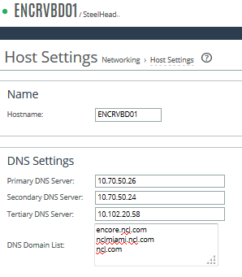
Open the SteelHead GUI: https://pri.ip.address
Sign in to the GUI as admin

Networking > Host Setting

Hostname:
Primary DNS Server:
Secondary DNS Server:
Tertiary DNS Server:
DNS Domain List:

The following is the DNS Settings for nclmiami domain:
DNS Servers: 167.118.162.155, 167.118.162.156,
10.100.20.90, 10.100.20.91, 10.100.20.92
Domain List: nclmiami.ncl.com, ncl.com

Test DNS at the end of the page using nclmiami.ncl.com or the ship domain.

Save Configuration

ADMINISTRATION

Licensing
ADMINISTRATION > Maintenance > Licenses
Before performing any other task, is mandatory to license the device.
First you need to setup PRI (Base Interface) IP and DNS to automatically license the device. If the PRI address is allowed to go to internet the steelhead will update licenses automatically Fetch Update Now bottom.
If automatically licensing doesn’t work; you must follow the guide to manually licensing the device.

Upgrade
ADMINISTRATION > MAINTENANCE > Software Upgrade
There is a strict order to follow when upgrading the software, depending on the current version on the appliance. You must look up the sequence for the destination RiOS version and the version intallaed, Riverbed support site. You must follow the correct sequence.

Some RiOS software are in \\netsrv1\wwwroot\RIVERBED folder.

Versions:
The following are the standard that we want the get; not all the devices support these versions as they are End of Software (EoS), for those ones upgrade to the latest supported.
Shipside: RiOS 9.7.1 ----> 9.9.1
Shoreside: RiOS 9.8.1 ----> 9.9.1

Date/Time
ADMINISTRATION > SYSTEM SETTING > Date/Time
Time Zone: US/Eastern
Use NTP Time Synchronization

When you change the Time Zone, you will be asked to re-Sign in.

NTP Servers
- Disable all default NTP servers, do not delete it.
- Datacenters 10.100.0.12, 10.102.0.12
- Ships: ntp.shipname.ncl.com

SNMP – Basic
ADMINISTRATION > SYSTEM SETTING > SNMP Basic
Enable SNMP Traps
System Contact: Global Network Engineering
System Location: Site/Ship Name to match the Solarwinds Sites
Read-only Community string: nclpub

EMAIL
ADMINISTRATION > SYSTEM SETTING > Email
SMTP Server: forwarder.shipname.domain.com
Report Events: ShipboardNetworkEngineering@ncl.com, global-network-engineering-ops@ncl.com
Report Failures: ShipboardNetworkEngineering@ncl.com, global-network-engineering-ops@ncl.com
Override Default Sender’s Address: global-network-engineering-ops@ncl.com
Report Failures to Technical Support
Create ticket to server team asking to use the forwarder.
global-network-engineering-ops@ncl.com,ShipboardNetworkEngineering@ncl.com

167.118.92.200 -- > forwarder.nclmiami.ncl.com

LOGGING
ADMINISTRATION > SYSTEM SETTING > Logging

Add Log Servers:
167.118.105.66 (only for NCL.COM Sites)
167.118.105.67 (only for NCL.COM Ships)
167.118.105.65 (only for PCH Ships)
Severity: Warning

Web Settings
ADMINISTRATION > SECURITY > Web Setting
Default Web Login:
Web inactivity timeout: 30
Check: Allow Session Timeouts when viewing Auto-Refreshing Pages
Generate a new Self-Signed Certificate
Organization Name: Norwegian Cruise Line
Organization Unit Name: Global Network Engineering
Locality: Miami
State: FL
Country: US
Email Address: global-network-engineering-ops@ncl.com
Validity Period: 3650

Security
(No implemented)
ADMINISTRATION > SECURITY > TACACS+
General Settings:
Select: TACACS+; Local
Uncheck: For RADIUS/TACAS+, fallback only when servers are unavailable

- Configure “NETWORKING”

Base Interface
This is the management IP address
Configure Primary interface as needed.
In-Path Interface
Configure In-Path interface as needed.

Flow Statistics (NetFlow) _ This is the default
Check Enable Application Visibility
Check WAN Throughput Statistics
Check Enable Top Talkers – 24h

- Configure “OPTIMIZATION”

NETWORK SERVICES

General Service Settings
Enable In-Path Support (requires an in-path IP first)

Peering Rules
Check: Enable Enhanced Auto-Discovery

Transport Settings
TCP Optimization
Ships: Bandwidth Estimation
Buffer Settings
Ships: 1000000 LAN / 3000000 WAN

Default: CX755L
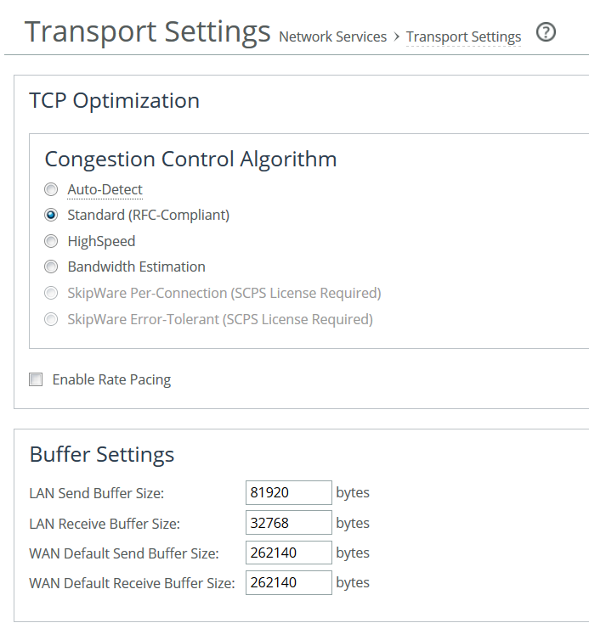

Failover Setting
In case of two steelhead in the ship we can enable Failover Support; this will sync data storage and connections between both devices. In case of a traffic failover the new active steelhead will have all the cache. One of the devices is the Master and other the Backup.
OPTIMIZATION > NETWORK SERVICES > General Service Setting
Failover Setting
Enable Failover Support
Current Appliance is: Master/Backup
IP Address: peer in-path interface

SSL
Certificate Authorities
Remove all pre-installed CA’s this will avoid future alarms due to expiring certificates.
Add “Entrust CA” certificate from \\wwwroot\Riverbed\Certificates

SSL Main Settings
Enable SSL Optimization
Add NCL.com and RSSC.com root certs

SECURE PEERING
Generate a new Self-Signed Certificate(replace)

Norwegian Cruise Line
Global Network Engineering
Miami
Florida
global-network-engineering-ops@ncl.com

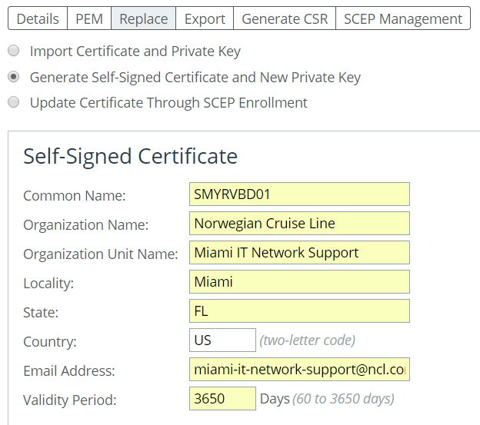

PROTOCOLS
SMB2/3
Enable SMB2/SMB3 optimizations
MAPI
Enable encrypted optimizations (NTLM Transparent Mode)

HTTP
Enable:
Stream Splitting
SharePoint: FPSE, WebDAV

Optimization Rules

FortiAnalyzer
This is an encrypted traffic that riverbed is unable to optimize, create a passthrough.
- Create Host Label FortiAnalyzer 10.100.21.115/32
- Create passthrough rule to destination 10.100.21.115/32 port: 3000 Description: Shoreside FortiAnalyzer
! Depending of the version, you can setup the rule using destination the Host Label.

AD Replication
Solution Number: S20240
Active Directory replication traffic between Windows Domain Controllers is both compressed and encrypted. There is no way for the SteelHead to decrypt this traffic.
- Create a Port Label: AD-RPC 135, 49152-65535

Host Label for the Domain Controllers
Ship domain controller NCL-shipname-ADs

seaweb
167.118.162.125/32
167.118.162.178/32
167.118.191.4/32

SSL seaweb.ncl.com

!To review:on Jade review PassThrough_Ports label.

Host Label without_steelhead
To avoid optimization to destination without steelhead.
To Site No Riverbed

- Additional Tasks

Configure for TACACS+

Once the system goes into production, the Self-Signed Peer Gray-List must be reviewed to move peers to the white-list.
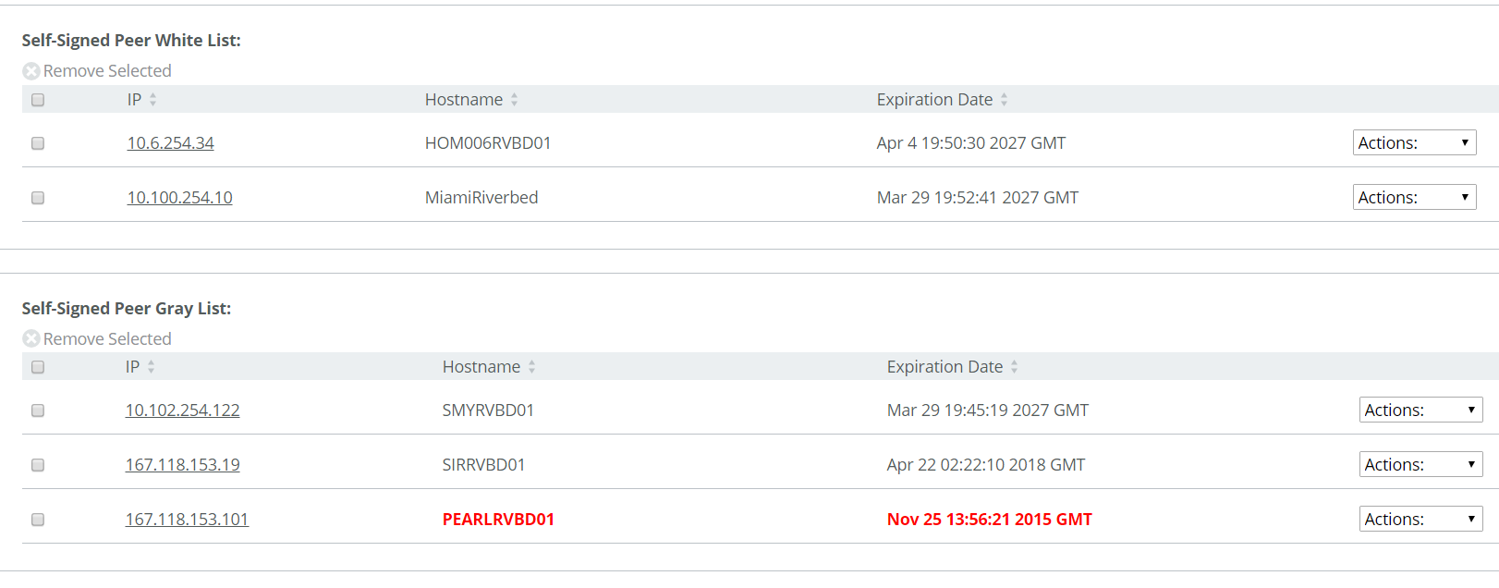
For all peers in the Gray-List, under Actions, select Trust.

Configuring QOS

- Create Network Applications

  - Goto Networking, Applications

  - Create all of the following applications:

APP-CITRIX-FARM-MIA-T2
10.100.48.0/23
Custom Application
Other
Medium Critically

APP-CITRIX-FARM-SMY-T1
10.106.48.0/23
Other
Medium Critically

APP-CITRIX-FARM-SMY-T2
10.102.48.0/23
Other
Medium Critically

APP-ELAVON
198.203.192.219 fusebox.elavon.net
198.203.192.219/32
Web Services
Highest Critically

APP-EVERI-ATM
173.226.121.5 BARRACUDA VPN HUB
Other
Highest Critically

APP-EVERI-CASHCLUB
173.226.121.18 xview.gcacashclub.com
173.226.121.18/32
Web Services
Highest Critically

APP-NOVATE
162.13.108.124 fexcogateway.fexcodccapps.com
162.13.108.124/32
Web Services
Highest Critically

ICMP
Transport Layer Protocol: ICMP
Network Monitoring
Medium Critically

SHIP-NET-MGMT
10.X.0.0/24
Networking
Medium Critically

seaweb
seaweb.ncl.com
seaweb.ncl.com/*
Web Services
Highest Critically

fexcogateway
fexcogateway.fexcodccapps.com
162.13.109.113
162.13.108.124
Web Services
Highest Critically

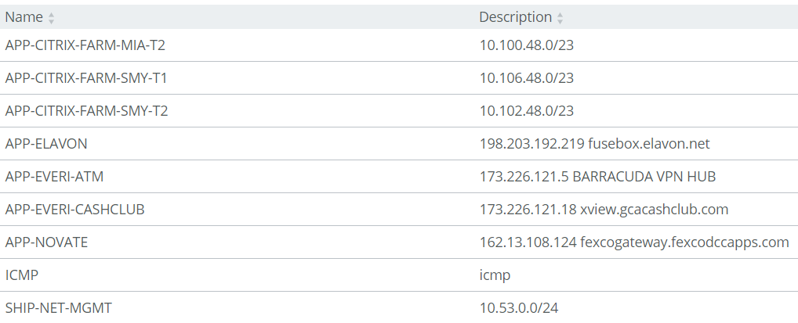

  - IP Addresses for all APPS should be in the destination field, except for SHIP-NET-MGMT, where the IP address should be in the SOURCE field.

- Create QOS Profile “Marking”

  - Goto Networking, Quality of Service

  - Under QOS Profiles, Add a QoS Profile named “Marking”

  - Add all of the following Applications to the profile

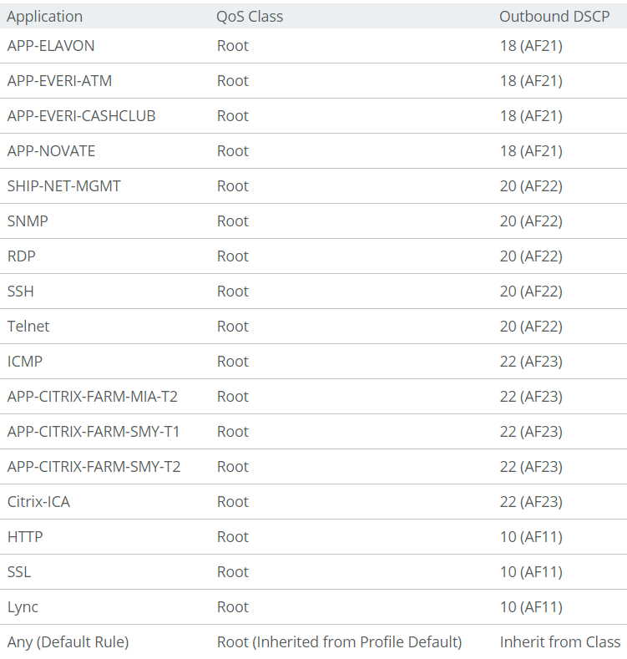

- Go to Networking, Sites & Networks

- Add a network
Name: VSAT

- Edit site Default Site
  - Rename to SHORESIDE”
  - Select Outbound QoS Profile: “Marking”

- Edit site “Local Site”
  - Add only the ship subnets, like 10.X.0.0/16
  - Some ships can have others old subnets.

- Goto Networking, Quality of Service
  - Enable Outbound QoS Marking
  - Click “Save”

- Test by pinging a 10.x.0.x host in the ship and ensure replies come back tagged as AF21

In case two riverbed in Ship

Add to Riverbed Asset
QoS
Solarwind
Block HTTP mgmt only HTTPS

DNS (to document)
10.X.50.24
10.X.50.26

Upgrade the Software to RiOS 9.7.1 (if supported)

NTP
SMTP relay (Email)
SMB signed
Domain join
Add steelhead to the CMC
SSL/TLS1.2

Citrix Optimization
Independent Computing Architecture (ICA)
Citrix ICA Citrix ICA ports 1494 and 2598

